ECAO3O5- SIGNALS AND SYSTEMS
NAME: S.GOKUL
REG NO: 192512373

Experiment No.: 4
Title: Verification of System Properties: Linearity, Time Invariance, Causality and Stability
Objective (i) To verify the linearity and time-invariance properties of continuous-time and discrete-time systems using suitable input signals and system responses
AIM
To verify the linearity and time-invariance properties of a continuous-time system using suitable input signals and system responses in MATLAB.
APPARATUS / SOFTWARE REQUIRED
1. Computer / Laboratory PC
2. MATLAB software (with Signal Processing environment)
THEORY
A system is linear if it satisfies both homogeneity, T{a·x} = a·T{x}, and additivity, T{x₁ + x₂} = T{x₁} + T{x₂}; together these give the superposition principle T{a·x₁ + b·x₂} = a·T{x₁} + b·T{x₂}.
A system is time-invariant if a time shift in the input produces the same shift in the output: if y(t) = T{x(t)}, then T{x(t − t₀)} = y(t − t₀). In this experiment the test system y(t) = 2x(t) is used, and the linearity error and time-invariance error are computed numerically; an error of nearly zero confirms the property.
FORMULAE USED
Linearity: T{a x₁ + b x₂} = a T{x₁} + b T{x₂}
Homogeneity: T{a x} = a T{x}
Additivity: T{x₁ + x₂} = T{x₁} + T{x₂}
Time invariance: T{x(t − t₀)} = y(t − t₀)
PROCEDURE
- Start MATLAB and define the time vector t = −1 to 1 s with a step of 0.001 s.
- Generate two test inputs x₁(t) = sin(2π5t) and x₂(t) = cos(2π5t); take a = 2, b = 3.
- Define the test system y(t) = T{x(t)} = 2x(t).
- Compute the output for the combined input a·x₁ + b·x₂ and compare it with a·T{x₁} + b·T{x₂} to obtain the linearity error.
- Delay the input by t₀ = 0.2 s, compute the system output and compare it with the correspondingly delayed original output to obtain the time-invariance error.
- Plot the linearity error and the time-invariance error and display the maximum errors.
- Classify the system based on the errors obtained.

PROGRAM (MATLAB CODE)
% Experiment 11: Linearity and Time Invariance
clc; clear; close all;
t = -1:0.001:1;
x1 = sin(2*pi*5*t); x2 = cos(2*pi*5*t);
a = 2; b = 3; t0 = 0.2;
T = @(x) 2*x;
lhs = T(a*x1+b*x2);
rhs = a*T(x1)+b*T(x2);
linError = max(abs(lhs-rhs));
xDelay = sin(2*pi*5*(t-t0));
lhsTI = T(xDelay);
rhsTI = T(x1);
rhsTIshift = interp1(t,rhsTI,t-t0,'linear',0);
tiError = max(abs(lhsTI-rhsTIshift));
figure;
subplot(2,1,1); plot(t,lhs-rhs); grid on; title('Linearity Error');
subplot(2,1,2); plot(t,lhsTI-rhsTIshift); grid on; title('Time-Invariance Error');
fprintf('Linearity error = %g\n',linError);
fprintf('Time-invariance error = %g\n',tiError);
OUTPUT
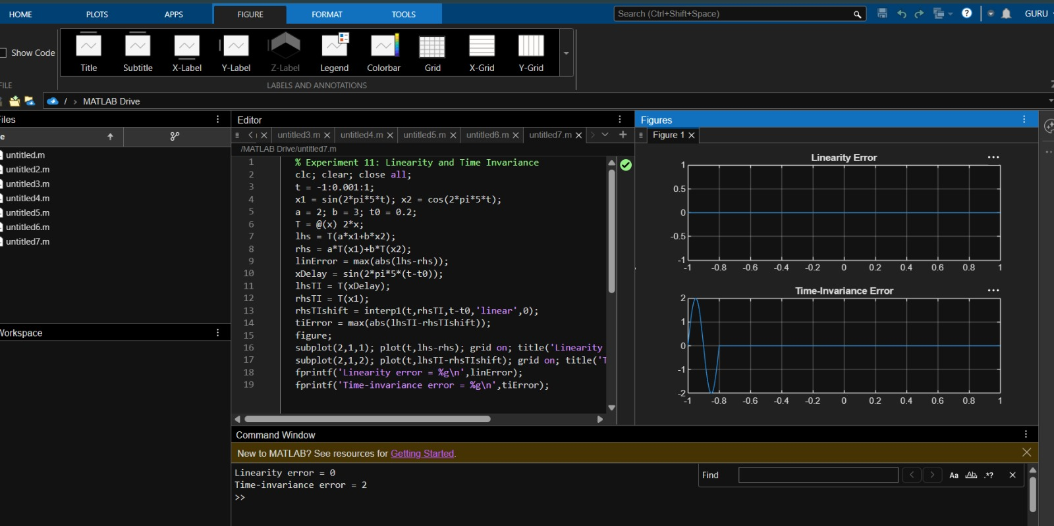
Fig. 4.1 Linearity error and time-invariance error for y(t) = 2x(t)

RESULT
The linearity error is zero over the entire interval, so the system y(t) = 2x(t) satisfies superposition and is linear. The time-invariance error is zero for t ≥ −0.8 s; the small non-zero segment between −1 s and −0.8 s is only a boundary effect of the interpolation (values outside the plotted range are taken as zero) and not a property of the system. Hence the system is linear and time-invariant.

LABORATORY PERFORMANCE ASSESSMENT RUBRICS:

Objective | Assessment Criterion | Excellent – 4 | Good – 3 | Satisfactory – 2 | Needs Improvement – 1 | Weightage | Marks(10) | Marks obtained
(i) To verify the linearity and time-invariance properties of continuous-time and discrete-time systems using suitable input signals and system responses. | Linearity Verification (Homogeneity & Additivity) | Correctly applies the homogeneity test and the additivity test (or the combined superposition test) to every CT and DT system. Chooses suitable input signals and scaling constants, compares the two responses accurately, and concludes linear or non-linear correctly. | Applies the linearity tests correctly to most systems, with minor errors in the choice of inputs, algebra or comparison. | Performs a basic linearity test (only one of homogeneity or additivity, or only some systems) with noticeable errors, and needs guidance. | Unable to apply or interpret the linearity test. | 20 | 2
 | Time-Invariance Verification (Time-Shift Test) | Correctly applies the time-shift test, comparing the response to the shifted input with the shifted output for every system. Handles systems with time-scaling or time-varying coefficients correctly and concludes time-invariant or time-varying correctly. | Applies the time-shift test correctly to most systems, with minor errors in shifting or comparison. | Performs a basic time-shift test with noticeable errors (for example shifting only the input or only the output), and needs guidance. | Unable to apply or interpret the time-invariance test. | 20 | 2
 | MATLAB Implementation & Numerical Verification | Writes correct MATLAB code with suitable time and index vectors to generate the test inputs, the system responses, the scaled, summed and shifted versions, and the plots. Computes numerical errors between the compared responses, and uses a tolerance to decide pass or fail. Plots have titles, axis labels and legends. | Code, plots and numerical comparison are correct, with minor errors in range, parameters, tolerance or labelling. | Code runs but has noticeable errors in vectors, shifting or error calculation, and needs assistance. | Unable to implement the tests or produce meaningful responses and plots in MATLAB. | 20 | 2
 | System Classification & Mathematical Justification | Independently classifies each CT and DT system as linear or non-linear and time-invariant or time-varying Supports each classification with correct mathematical working and with the waveform or error evidence from MATLAB. | Classifies most systems correctly, with minor errors or limited justification. | Gives basic classifications. Justification is incomplete or not linked to the test results, and needs guidance. | Unable to classify the systems correctly or justify the classification. | 20 | 2
 | Engineering Analysis, Record & Interpretation | Provides a technically accurate interpretation of the results and links them to the importance of linear time-invariant (LTI) systems Maintains a complete, well-organized record with code, plots, observations and conclusions. | Maintains a proper record with minor omissions. Interpretation is correct but brief. | Record and interpretation are basic or partly incomplete, and need guidance. | Incomplete record, limited or no interpretation of the results. | 20 | 2
 |  |  |  |  | Total | 100 | 0

